Open Education
39 April 20, 2016

If you want to change student learning then change the methods of assessment – Chuckett and Sutherland

…hands of both teacher and learner…

Elsewhere I reported on a visit to the Provincial Learning Materials Distribution Centre; while there, I picked up a copy of the curriculum guide for Grade 10 Math. The Guide was developed by the Western and Northern Canadian Protocol, a consortium of Western Provinces, and was adopted by a other Provinces including PEI. I enjoyed math in school and still feel that my math skills are quite adequate for good citizenship, however, I must confess that I really didn’t understand most of the outcomes in the guides.

My confusion my result from Guides being curriculum based rather than education based. the differences are not always clear. There are a number of approaches: (1) educational outcomes as William Spadey proposed, (2) curriculum outcomes as found generally in our public schools, and (3) competencies used by some colleges, universities and, I’m told, also in Quebec.

I am of the view that learners, especially those in senior grades, should be provided copies of outcomes; this is a way that all are reading from the same page. Not having the outcomes, it seems to me, is like not providing choir members with music notes.

In my experience, putting outcomes in the hands of both teacher and learner is standard practice. To do so, however, will require an additional level of detail in the analysis process.

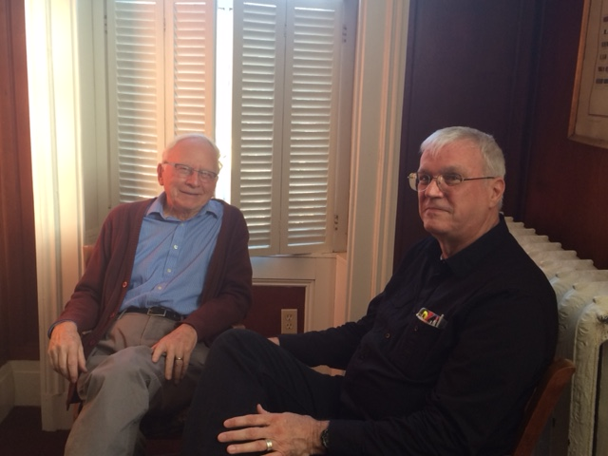
Don Glendenning and Tom White-Hassler
continue the discussion after a recent meeting

Effectiveness or efficiency

A couple of items caught my eye recently. One was an announcement from Ontario about adding reading specialists to schools; the other was about converting 32 administrative positions to teaching positions in PEI. To my way of thinking, both are examples of increasing efficiency.

Literacy for the 21st century

Keep an eye out for a presentation about PEI results on the Programme for the International Assessment of Adult Competencies (PIAAC). The presentation will provide information on where PEI stands compared to the rest of Canada, and, in particular, to other Atlantic provinces.

Don Glendenning, Editor
Education 20/20 Inc.
101 Kent St., PO Box 624 / 101, rue Kent, B.P. 624
Charlottetown, PEI / Charlottetown (Î.-P.-É.) C1A 1M0
Tel./Tél. : 902-892-2060,
Email/Courriel : pei@education2020.ca
URL : www.education2020.ca

